**Week 2**

**Day - 1**

**Backend Development**

**Create a simple CRUD operation using Laravel.**

1. **Create a project in laravels:**

composer create-project laravel/laravel crud-app (through composer in terminals)

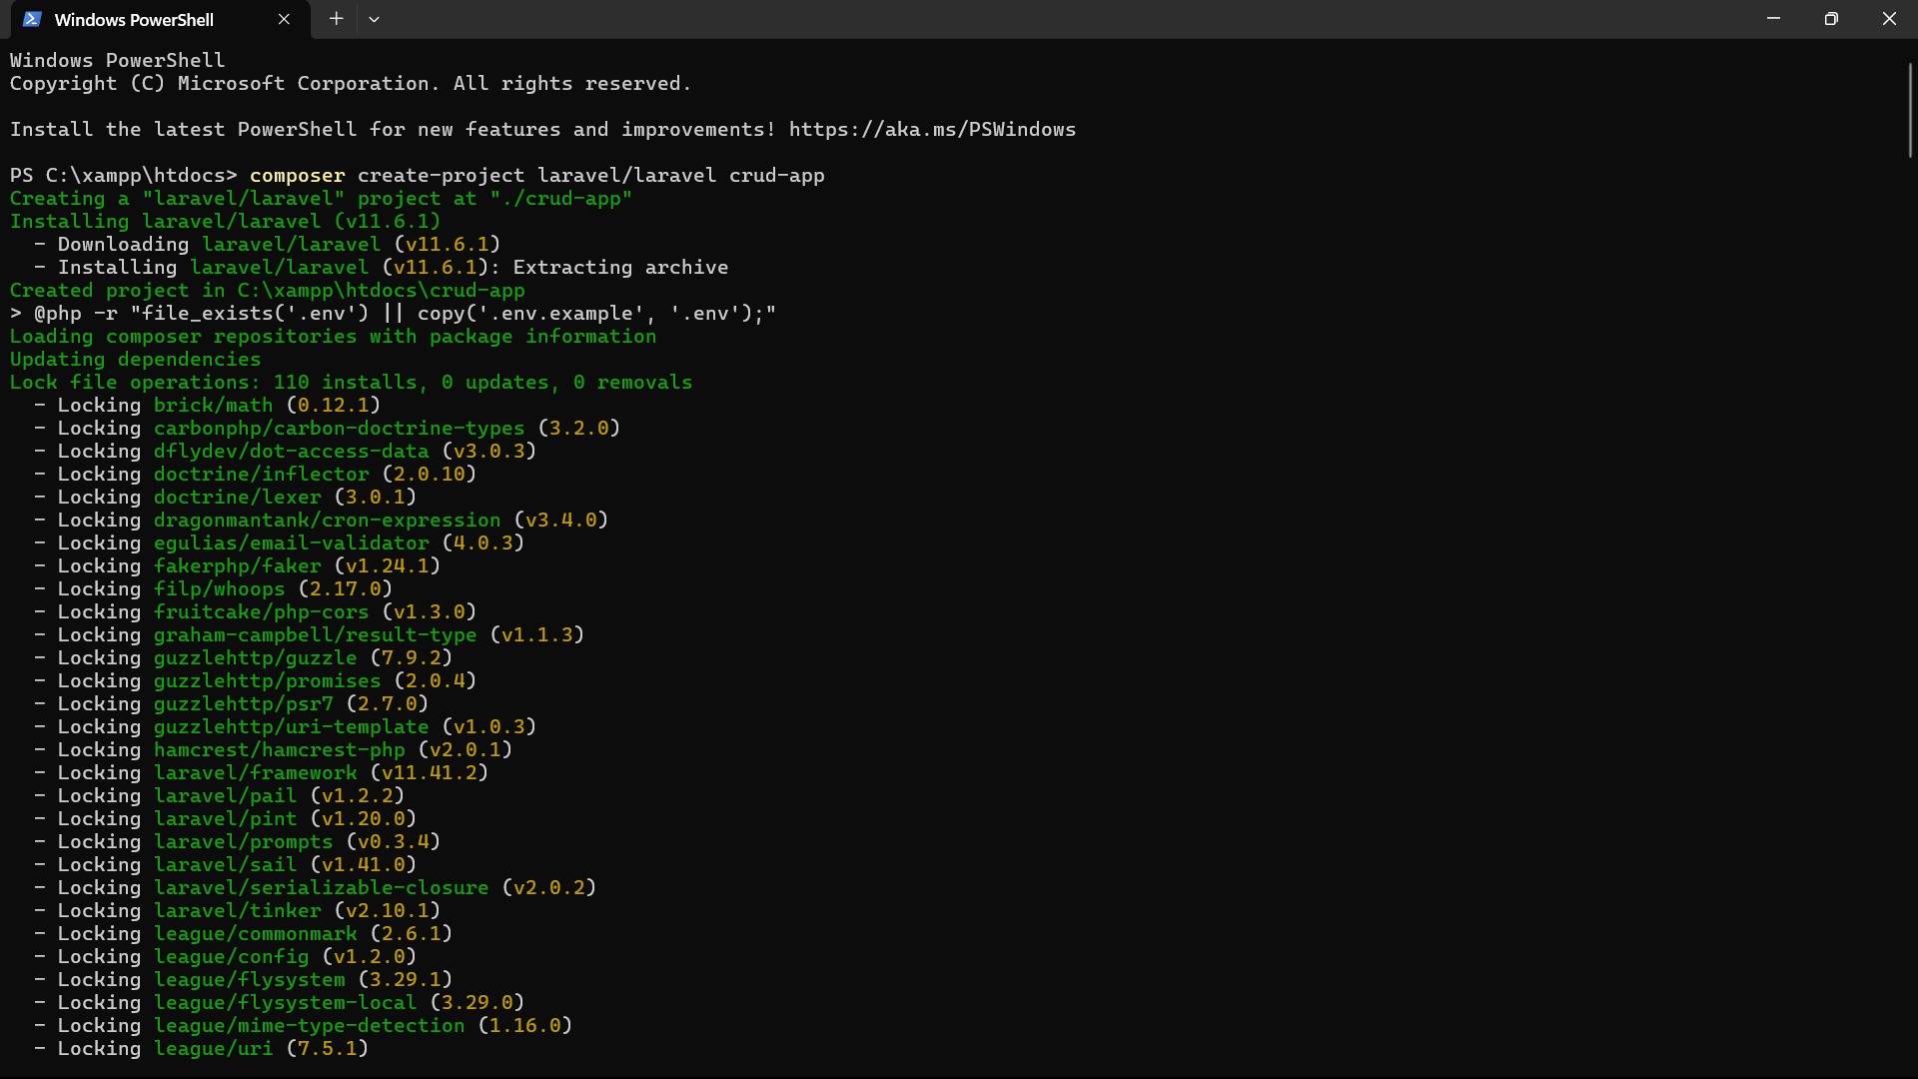

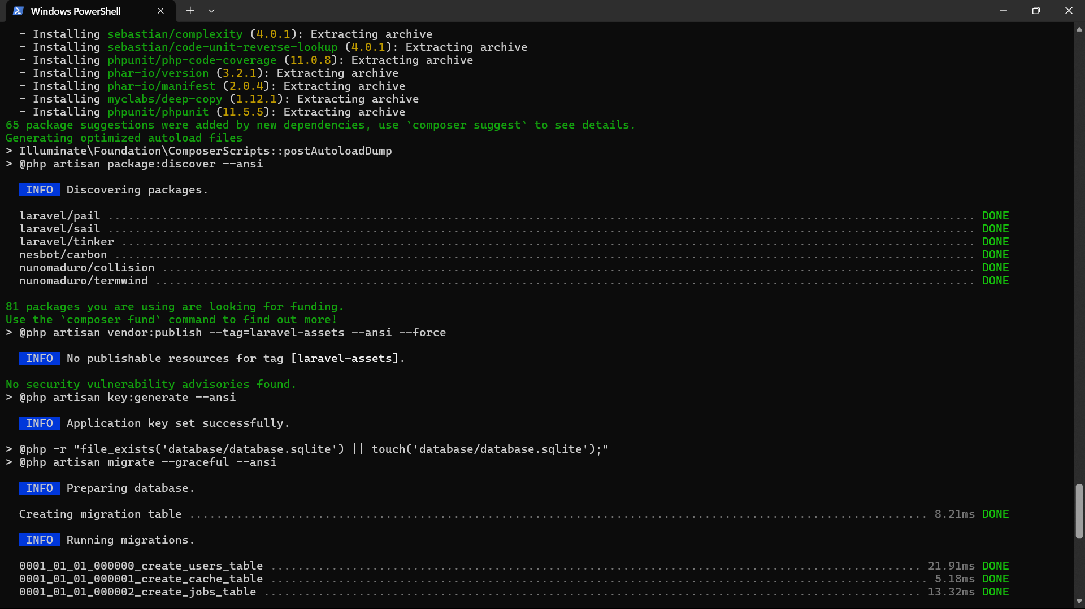

Navigate to the project directory: **cd crud-app**

**Step 2 - Configure Database:**

* Create database from MySql: in create database section:**crud_db**

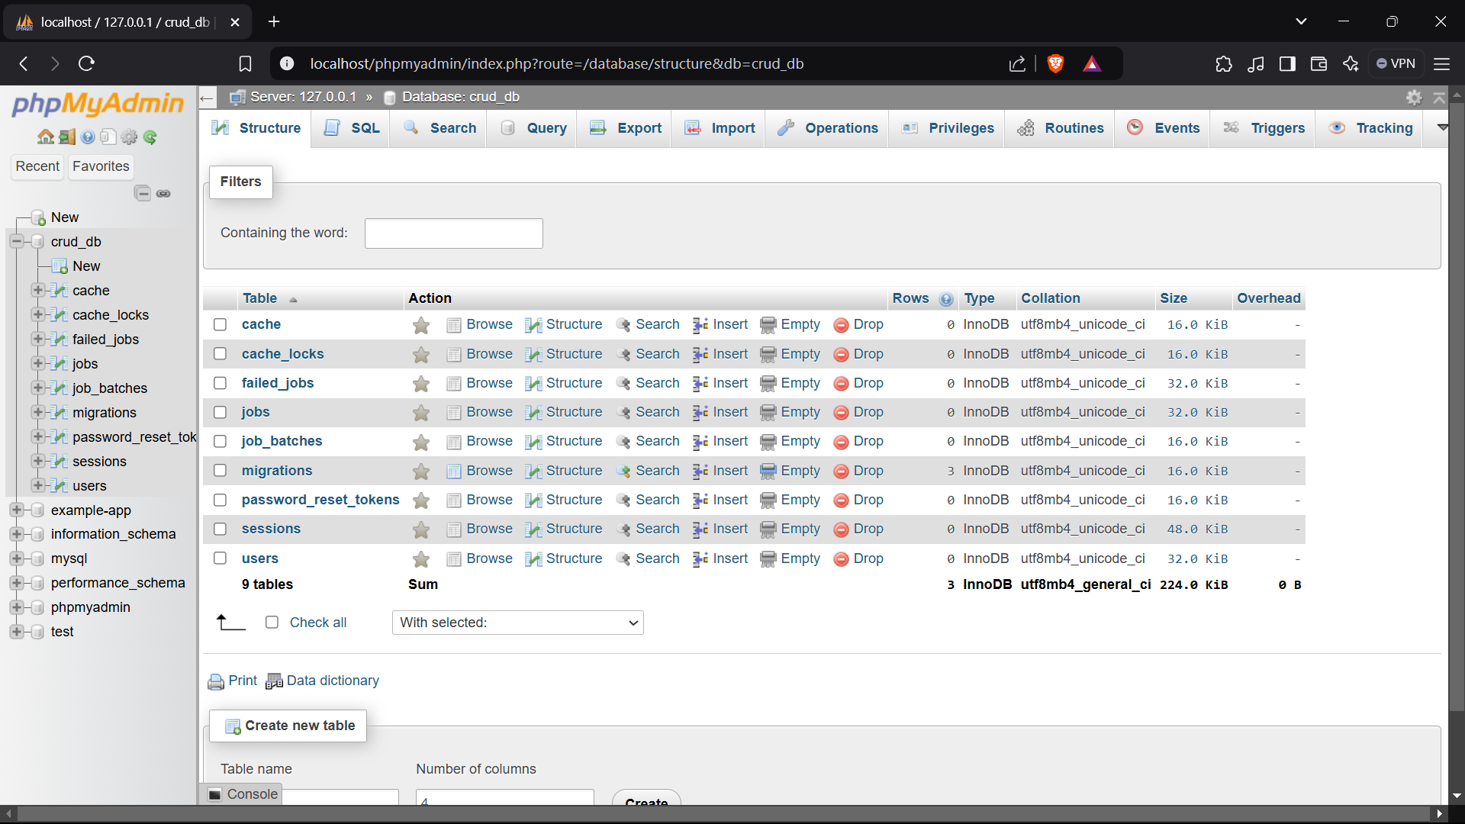

* Update Laravel’s Database Configuration through **.env** file in project folder

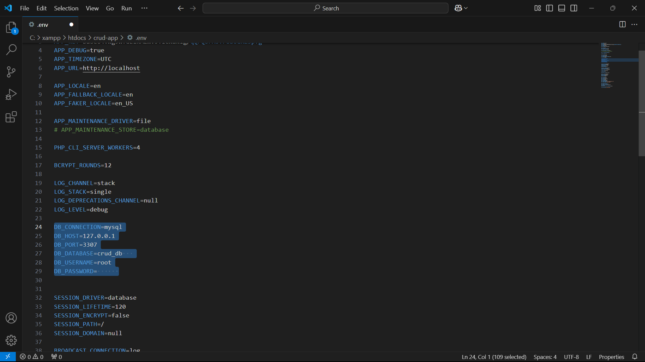

* Then Clear Config Cache: **php artisan config:cache**
* Run Migrations (Create Tables): **php artisan migrate**

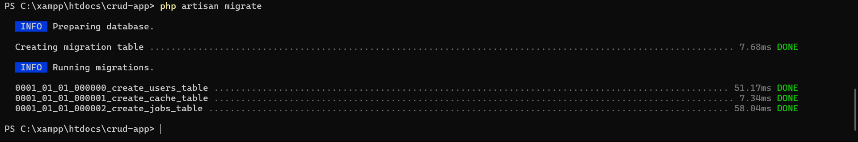

**Step 3: Create a Model & Migration**

* Created a Model and Migration (**php artisan make:model Product -m**).



* Define Table Structure in Migration:

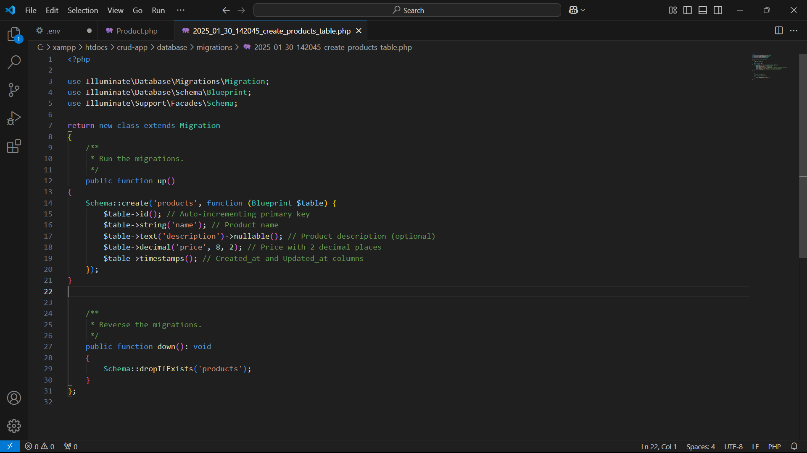

* Run the Migration: Executed the migration (**php artisan migrate**).



* Define the Model for Product **app/Models/Product.php**

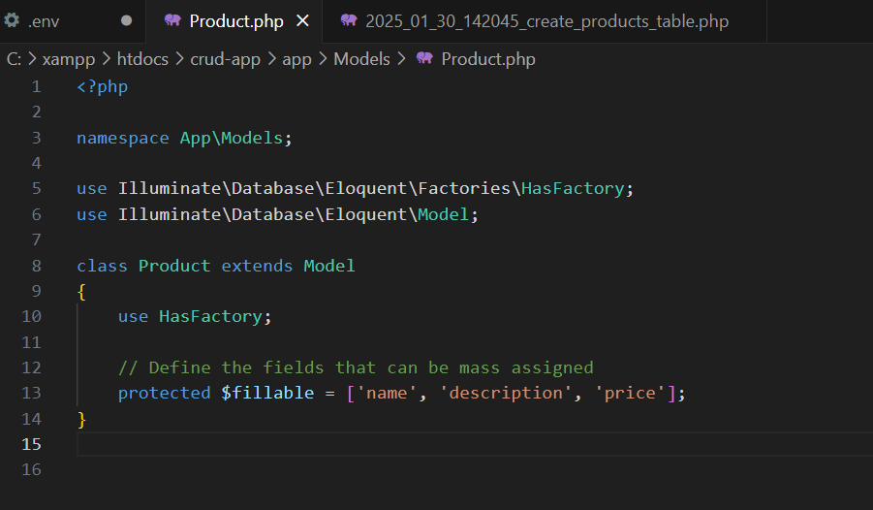

**Step 4: Creating a Controller in Laravel**

* Open Your Terminal and Run This Command



* Locate the Controller File: app/Http/Controllers/PostController.php
* Understanding the Controller Methods

Explanation of Each Method

1. index() - Fetch All Posts

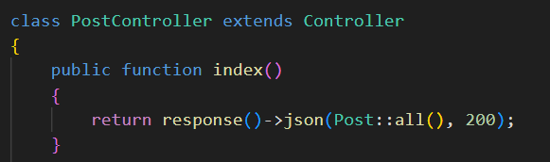

1. store() - Create a New Post

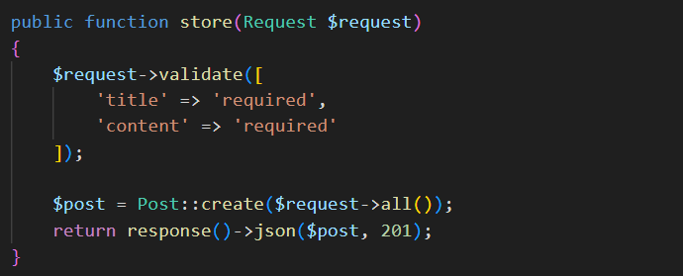

1. show() - Fetch a Single Post

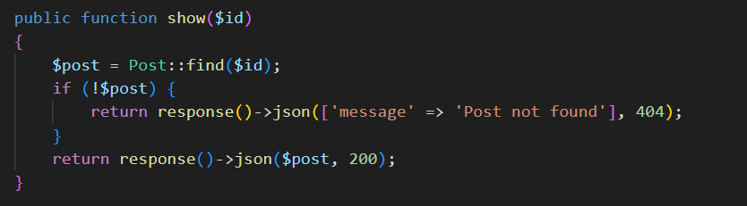

1. update() - Modify a Post

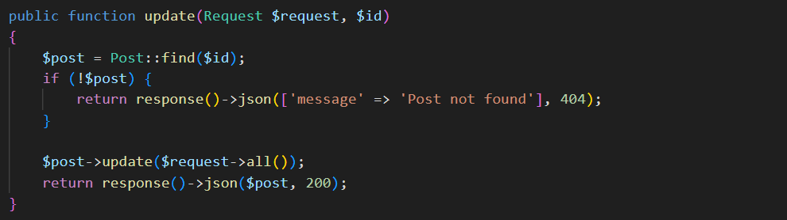

1. destroy() - Delete a Post

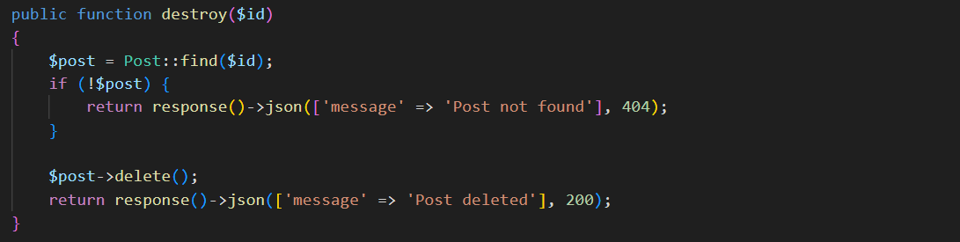

* Connect the Controller to API Routes

1. Open the file: routes/api.php

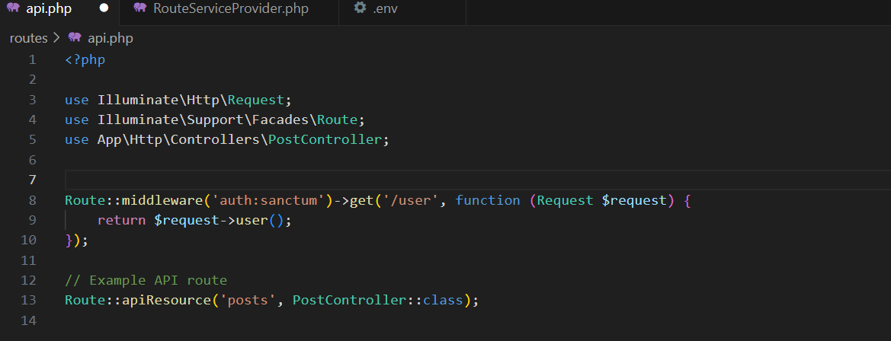

**Step 6: Test API**

* Ensure Your Database is Running

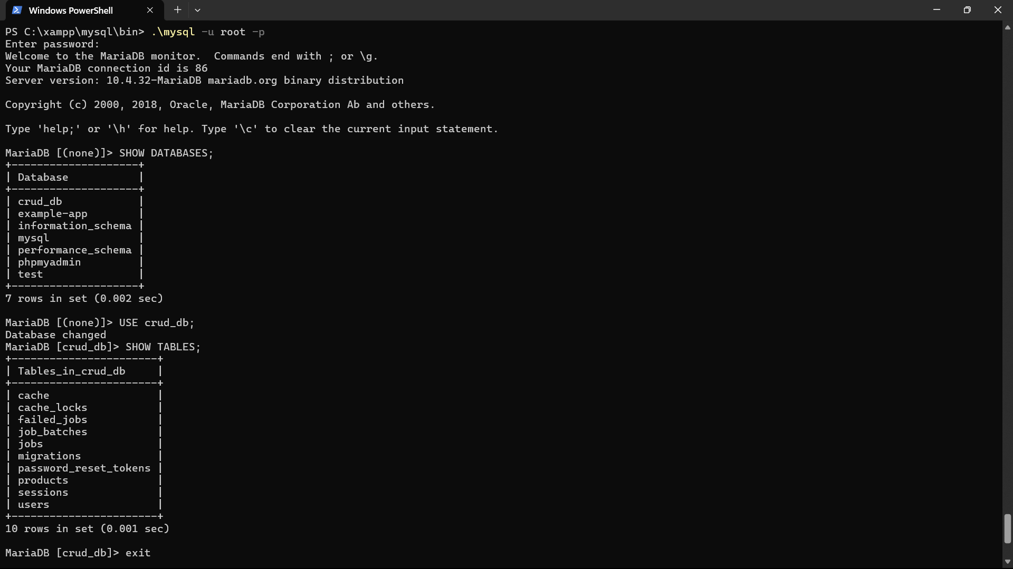

* Configure **.env** File

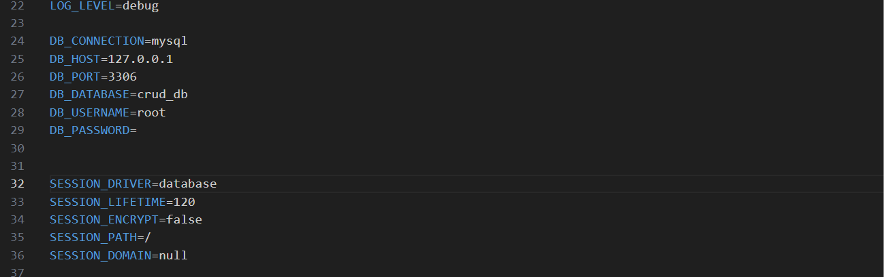

* Run Database Migrations

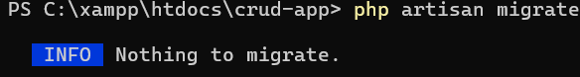

* Start Laravel Development Server

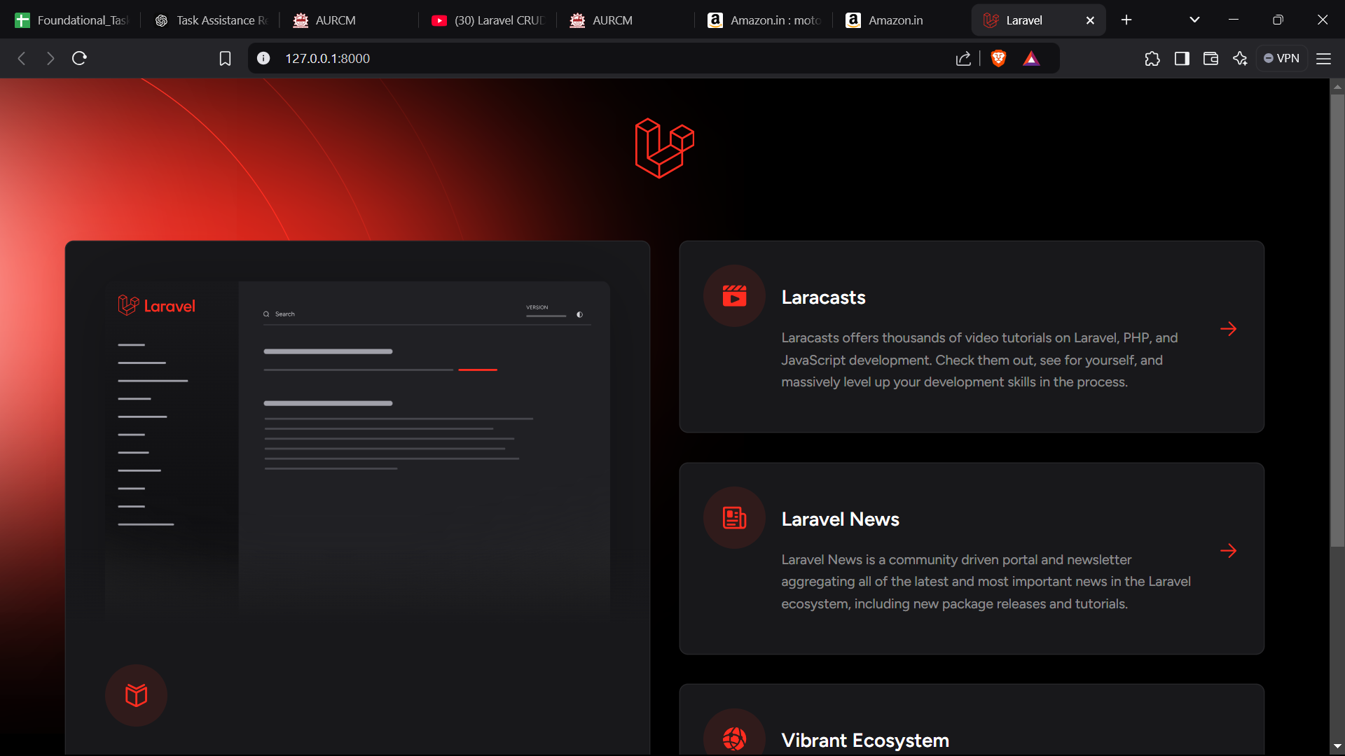

* Create a Post

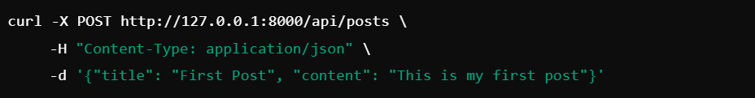

* Get all post



* Get single post



* Update a post

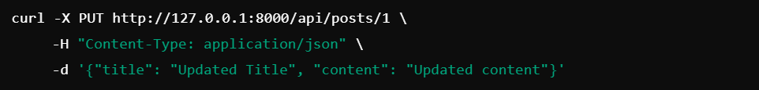

* Delete a post

